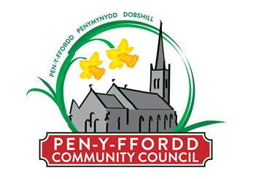

Publication of audited accounts for the year ended 31 March 2020

Regulation 15(5) of the Accounts and Audit (Wales) Regulations 2014 (as amended) requires that by 30 September 2020, Penyffordd Community Council publish its accounting statements for the year ended 31 March 2020 together with any certificate, opinion, or report issued, given or made by the Auditor General.
The accounting statements in the form of an annual return have been published on the Council’s website. However, the accounts are published before the conclusion of the audit. Due to the impact of COVID-19, the Auditor General has not yet issued an audit opinion.

