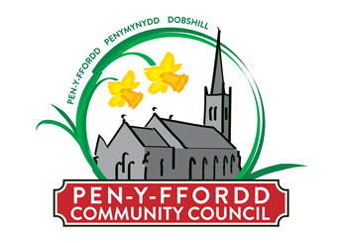
Grant Aid Application Form - 2021

Local Organisations are entitled to apply for financial assistance from the Community Council once a year where applications will be considered in the November Meeting.

To be considered for a grant, please complete the details below together with he attached Privacy Notice in accordance with the General Data Protection Regulations.

Please note the application must be accompanied by the latest audited financial statement or an up to date bank statement. Applications can not be considered without the information.

Name & Address of Organisation: ………………………………………………………………………………………………………………

………………………………………………………………………………………………………………………………..………………………………….

Brief Outline of Activities: ………………………………………………………………………………………………………..………………….

………………………………………………………………………………………………………………………………………………………..……………

Any Specific Purpose for Funding (continue on a separate page if necessary): ……………………………..…………...

……………………………………………………………………………………………………………………………………………………………………

Approximate Annual Outlay: ……………………………………………………………………………………………………………………….

Details and costs of the three main outgoings over the past year.
- ………………………………………………………………………………………………………………………………………………
- ……………………………………………………………………………………………………………………………………………….
- ……………………………………………………………………………………………………………………………………………….
Completed forms must be returned to the Clerk Mrs S A Hughes, 3 Old Chester Road, Ewloe, Deeside, Flintshire, CH5 3RU or via email to clerk@penyfforddcouncil.org no later than: Friday 5th November 2021
Before submitting your application, please ensure you have fully completed and enclosed the following:
Application Form Privacy Notice
Bank Statement or/latest Audited Financial Statement
If your application is successful, the council would like to process the grant via BACS directly into your group/organisations bank account. In order for this to be actioned, you will need to provide a copy of your latest bank statement which clearly shows the group/organisations name, bank account and sort code.

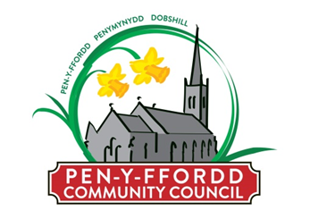

Privacy Notice for Grant Applicants

Penyffordd Community Council is the Data Controller under the new data protection law and will use the information you provide on this form in order to contact you about your grant application.

The legal basis for processing this data is your consent to do so. You can withdraw your consent at any time by notifying us. Our contact details to do so, or for any other queries, are Mrs S Hughes - Clerk, 3 Old Chester Road, Ewloe, Deeside, Flintshire, CH5 3RU Tel: 01244 537032 Email: clerk@penyfforddcouncil.org

We will keep your data for six years if your grant application is successful and for six months if your application is turned down plus the current financial year, which runs from 1st April to 31st March.

Your information will not be shared further.

Individuals have a number of rights under data protection law, including the right to request their information. You also have a right to make a complaint about our handling of your personal data to the Information Commissioner’s Office. ICO website (https://ico.org.uk/)

Information you provide will only be used for the stated purpose. Further information about the processing of your data can be found on our website (www.penyfforddcouncil.org)

You can contact the community council’s Data Protection Officer, Paul Russell (Microshade VSM): 2 Church Road, Knighton, Powys LD7 1EB. Tel: 07772 657446. Email: paul@microshadevsm.co.uk

REQUESTED INFORMATION:

Please provide a name address, email and telephone number so that we can send information relating to your grant application.

NAME:

ADDRESS:

EMAIL:

TELEPHONE:

Your declaration:

I understand the following:

You will use the information I have provided to provide me with information regarding my grant application.

If you need any further information, please contact the Clerk, Mrs S Hughes - Clerk, 3 Old Chester Road, Ewloe, Deeside, Flintshire, CH5 3RU Tel: 01244 537032 Email: clerk@penyfforddcouncil.org

DATE:

If you agree to being contacted in the future on other matters, please tick the relevant box:

Post Email Phone SMS

